**LAB 04 SQL Functions**

**Quiz**

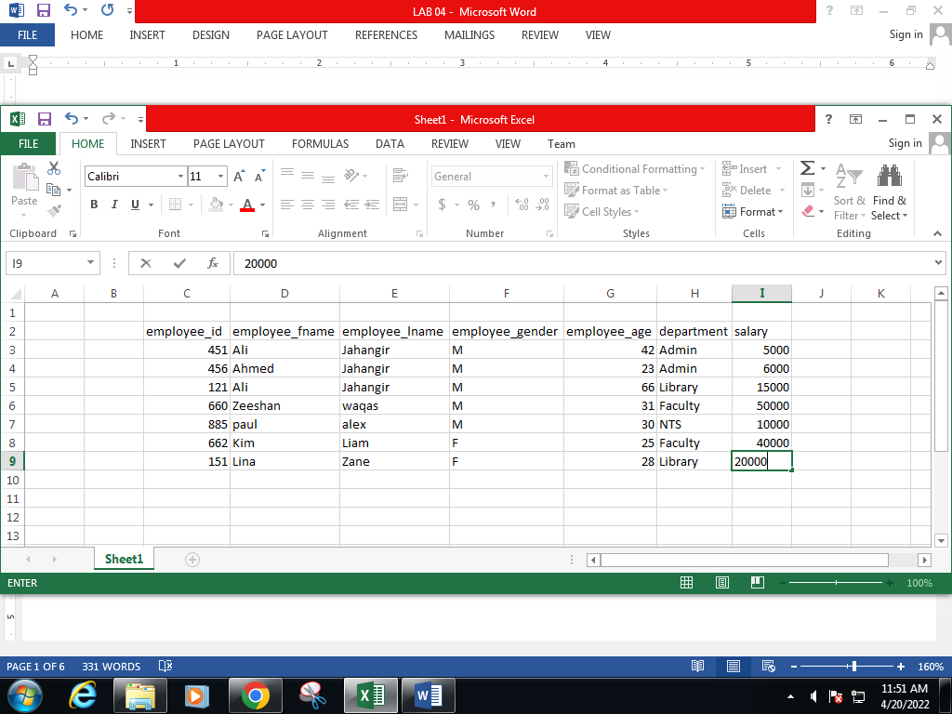

# OBJECTIVE(S)

* Learn column placement
* Learn string functions
* Learn math functions
* Learn SQL aggregate functions
* Learn about grouping rows

# AGGREGATE FUNCTIONS

An aggregate function performs a calculation on a set of values and returns a single value. Some common aggregate functions are given below. The general syntax of these functions (unless otherwise specified) is:

* **SELECT AGG_FUNCTION_NAME**(col_name) **FROM** tb_name;

| FUNCTION NAME | DESCRIPTION |
| --- | --- |
| AVG | Calculates the average for a set of values. **AVG** function ignores NULL values in the calculation. |
| SUM | Calculates the sum for a set of values. **SUM** function ignores NULL values in the calculation. |
| MAX | Returns the maximum value from a set of values. |
| MIN | Returns the minimum value from a set of values. |
| COUNT | Counts the number of rows in a table.  **COUNT**(*) – Counts all rows.  **COUNT**(col_name) – Counts non-empty rows.  **COUNT**(DISTINCT col_name) – Counts unique rows. |

|  |
| --- |
| TASK  * Display the average marks of students. * Display the maximum percentage. * Display the total number of students who have not yet been assigned a department. |

# 

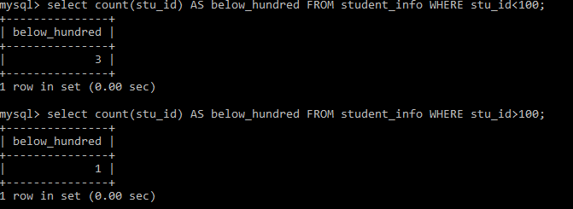

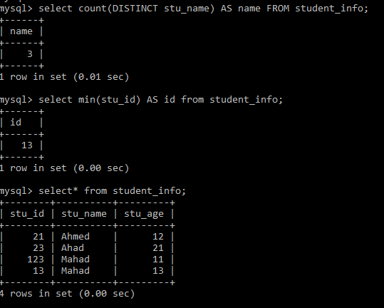

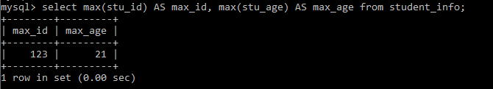

# GROUPING ROWS

GROUP BY clause: Groups a set of rows

HAVING clause: Filter condition with GROUP BY clause

## GROUP BY

The **GROUP BY** clause is used to group a set of rows of the table. The **GROUP BY** clause is often used with an aggregate function to perform calculation and returns a single value for each subgroup.

* **SELECT** col_name(s), aggregateFunc() **FROM** tb_name

**GROUP BY** col1_name, col2_name;

## HAVING

The **HAVING** clause is often used with the **GROUP BY** clause. We can apply a filter condition to the columns that appear in the **GROUP BY** clause.

* **SELECT** col_name(s), aggregateFunc() **FROM** tb_name

**GROUP BY** col1_name, col2_name

**HAVING** group condition(s);

## Illegal Queries Using Group Functions

* Group functions CANNOT be in the **WHERE** clause.
* **WHERE** clause CANNOT be used to restrict groups.
* **HAVING** clause is used to restrict groups.

|  |
| --- |
| TASK  * Display the number of students in each department. * Display the maximum percentage for each semester. List in order of decreasing semesters. * List the courses with more than two active enrollments. |

